**Password Cracking:**

The first information an attacker tries to obtain from a target is the account information and passwords of the target’s operating system. The process of attempting to guess or [crack](http://www.webopedia.com/TERM/C/crack.html) [passwords](http://www.webopedia.com/TERM/P/password.html) to gain access to a [computer](http://www.webopedia.com/TERM/C/computer.html) system or [network](http://www.webopedia.com/TERM/N/network.html) is called password cracking. Crackers will generally use a variety of tools, [scripts](http://www.webopedia.com/TERM/S/script.html), or [software](http://www.webopedia.com/TERM/S/software.html) to crack a system password. The goal of the cracker is to ideally obtain the password for [root](http://www.webopedia.com/TERM/R/root_server_system.html) ([UNIX](http://www.webopedia.com/TERM/U/UNIX.html)) or system and administrator ([Windows](http://www.webopedia.com/TERM/W/Windows.html), [NT](http://www.webopedia.com/TERM/W/Windows_NT.html)). Password cracks work by comparing every encrypted dictionary word against the entries in system password file until a match is found.

**Password Cracking Techniques:**

The following techniques are commonly used to crack passwords:

1. Physical theft
2. Guessing
3. Brute force attacks
4. Dictionary attacks
5. **Physical theft**: An individual can physically watch a password being typed or take a piece of paper on which it is written. **Dumpster diving** is also effective in terms of retrieving passwords.

**What is dumpster diving?**

 In the world of information technology, dumpster diving is a technique used to retrieve information that could be used to carry out an attack on a computer network. It isn't limited to searching through the trash for obvious treasures like access codes or passwords written down on sticky notes. Seemingly innocent information like a phone list, calendar, or organizational chart can be used to assist an attacker using [social engineering](http://searchsecurity.techtarget.com/definition/social-engineering) techniques to gain access to the network.

1. **Guessing:** Password guessing is an attack in which an attacker attempts to recover user credentials through the process of attempting to log in repeatedly. This is generally done by using commonly used or default passwords—attempting every possible combination until successful.
2. **Brute force attacks:** A brute force attack is an attack where every possible combination of letters, numbers, and symbols are tried in an attempt to guess a password. Brute force attacks are generally conducted with a program designed for that purpose.
3. **Dictionary Attack:**  Dictionary attacks use password dictionaries to try to guess every possible password within a limited range of actual words. It is a method of breaking into a password-protected computer or server by systematically entering every word in a dictionary as a [password](http://searchsecurity.techtarget.com/definition/password).

**Tools:**

1. **Hydra & xhydra (On line Password Cracking)**
2. **John the riper (jtr) (Off line Password Cracking)**

**The** tools used for cracking passwords are

1. **Hydra:** Hydra is a password cracker that supports TELNET, FTP, HTTP, HTTPS, LDAP, SMB, SMBNT, MySQL, REXEC, SOCKS5, VNC, POP3, IMAP. The fastest is generally POP3, then FTP and TELNET, with the slowest being IMAP Hydra uses a parallel processing technique that allows it to rapidly guess passwords. However, the speed with which this tool guesses passwords depends upon the type of protocol targeted. This tool allows for rapid dictionary attacks against network login systems.

**Step 1:** open hydra tool in kali Linux

Type **hydra** in termial

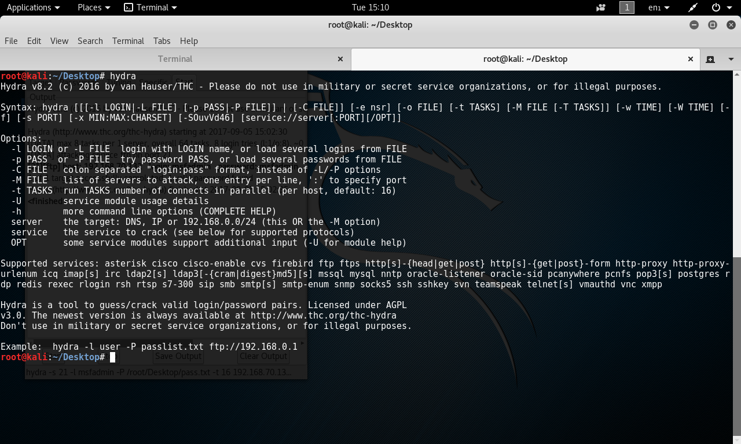

**Step 2:** type the below given command at terminal

hydra –l <username> -p <password> <ftp://ipaddress>

(or)

Hydra –L <username list(file)> -P <password list(file)> <ftp://ipaddress>

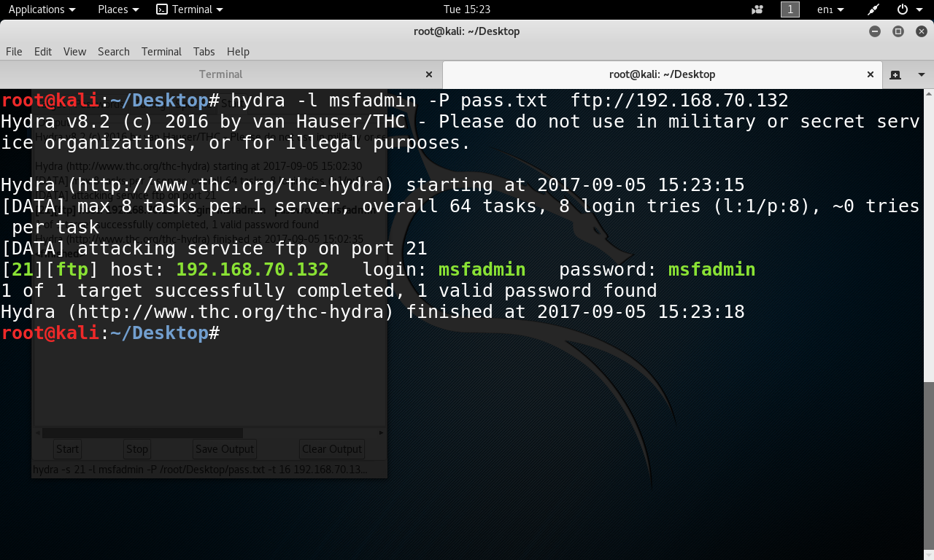

**Xhydra:**

**Step 1:** open terminal and type xhydra

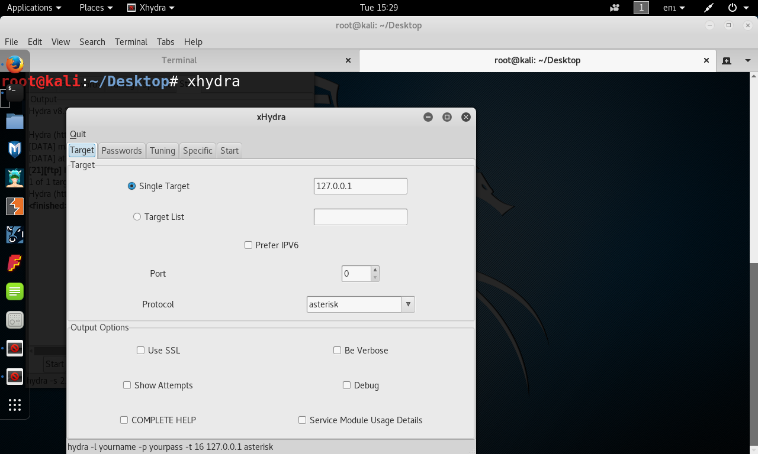

**Step 2**: Choose target

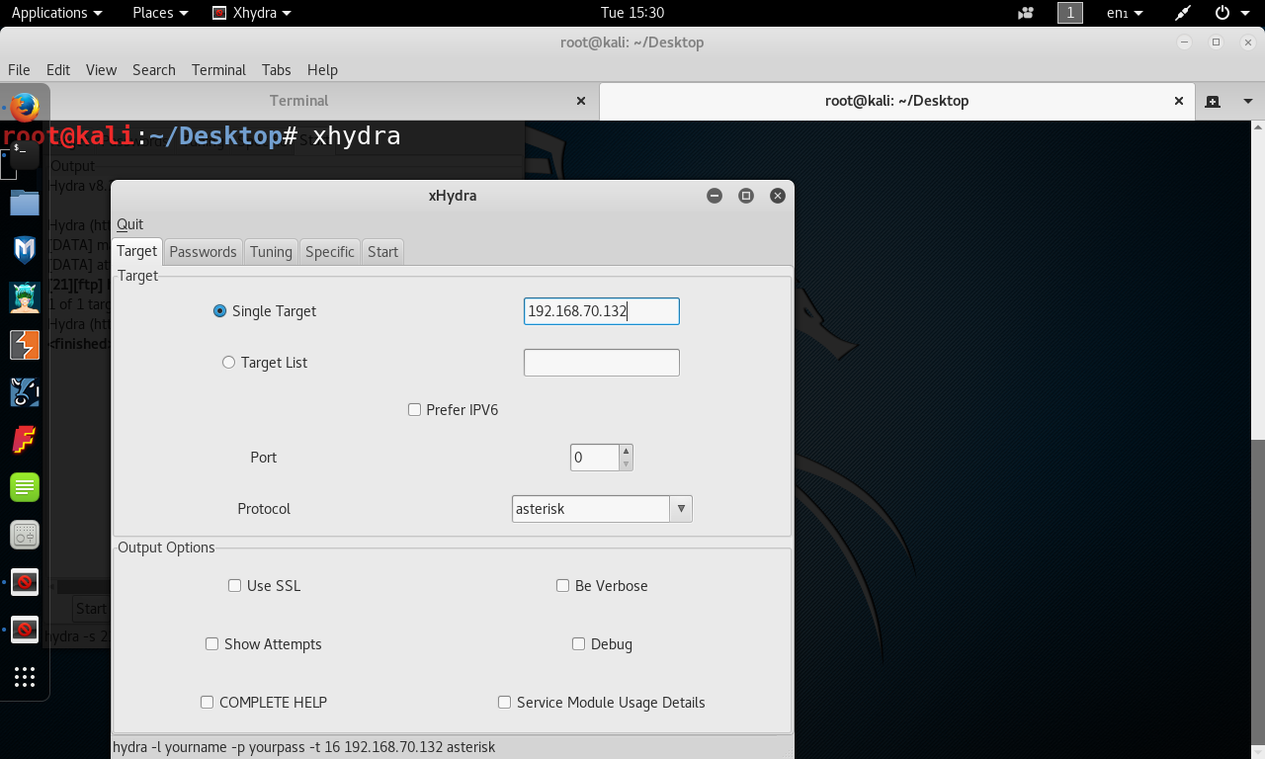

**Step 3:** Choose port no and protocol

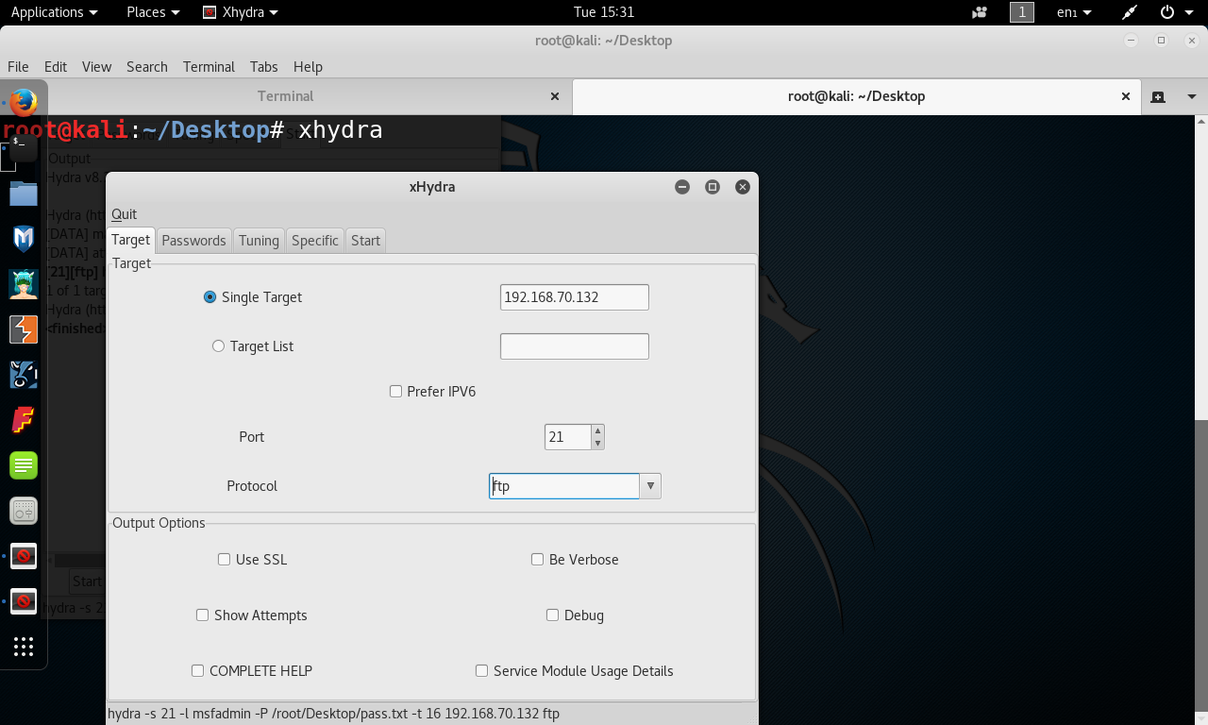

**Step 4:** choose user name and protocol

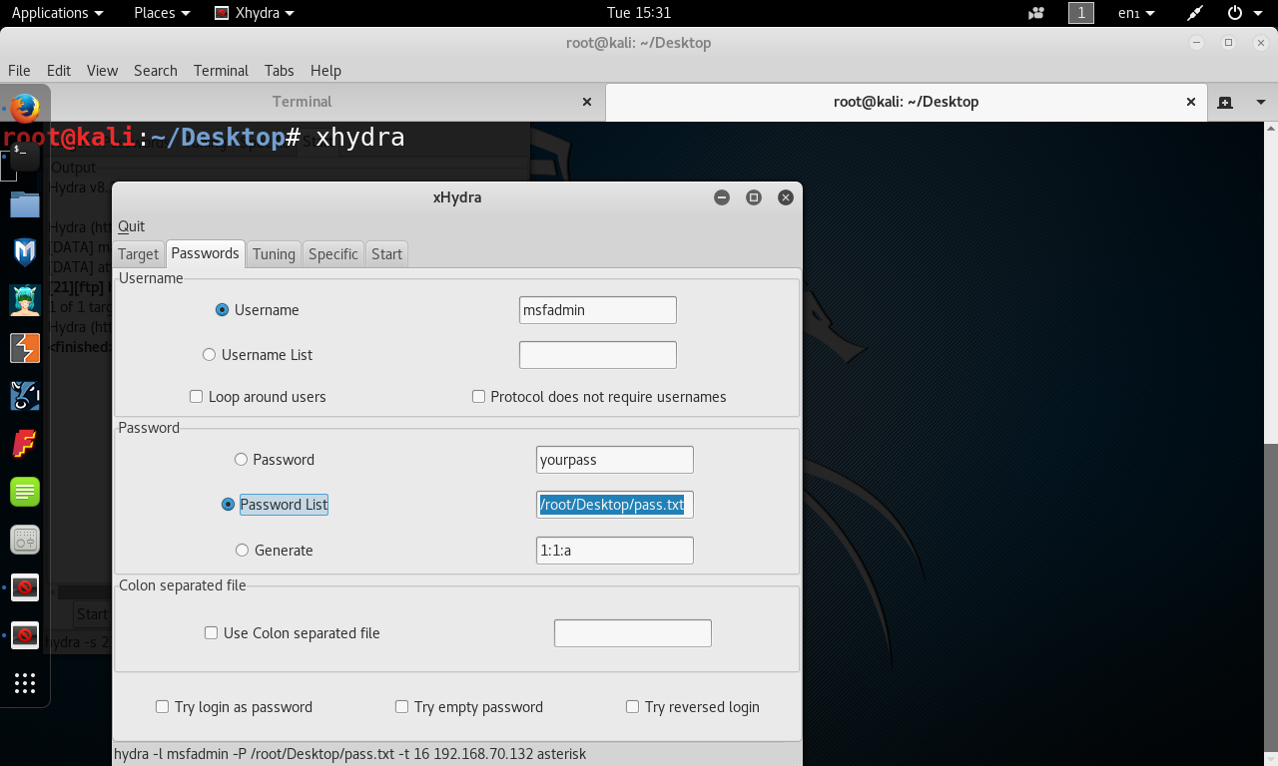

**Step 5:** click on start button

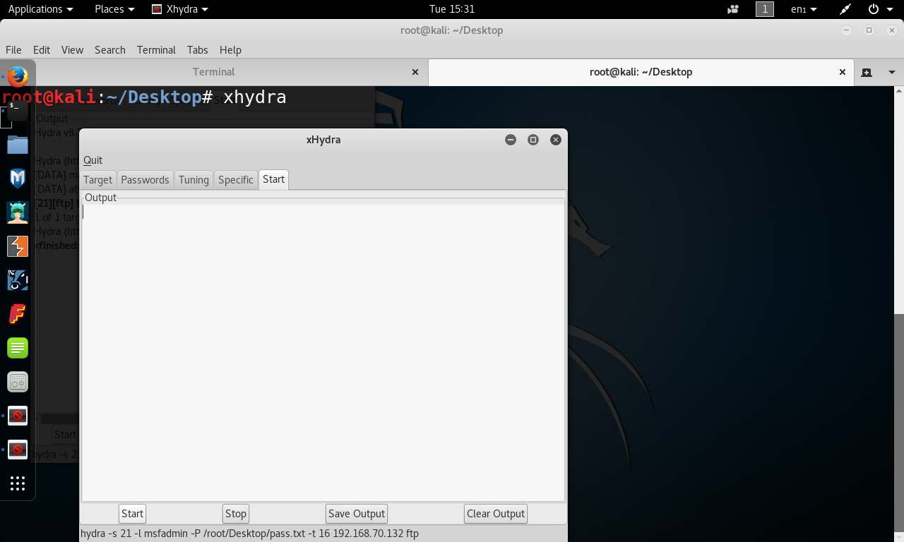

**Step 6:** now the output is displayed like given below.

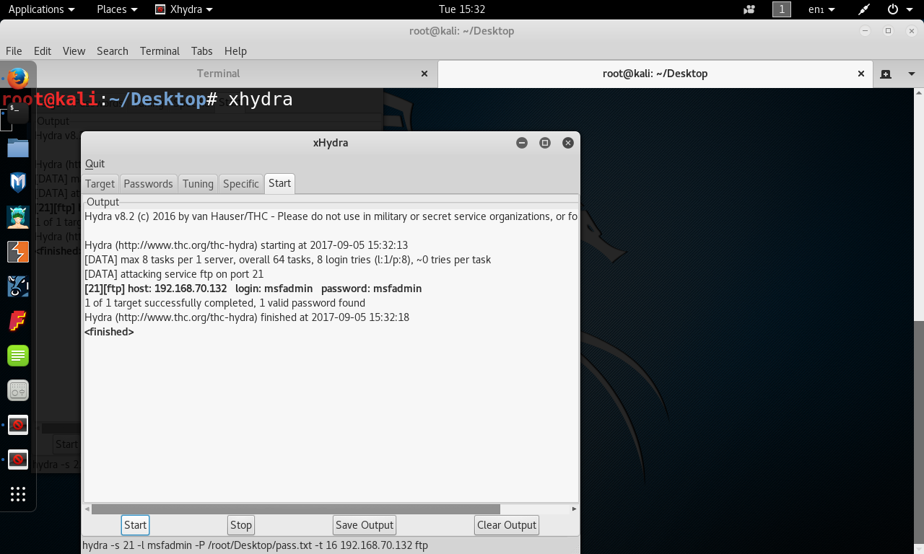

1. **John the riper:**  is probably the fastest, most versatile, and definitely one of the most popular password crackers available. It supports six different password hashing schemes that cover various flavors of Unix and the Windows LANMan hashes also known as NTLM (used by NT, 2000, and XP).it is currently available for many flavors of Unix, Windows, DOS, and OpenVMS. Its primary purpose is to detect weak Unix passwords, though it supports hashes for many other platforms as well.

**How it works?**

**Step1:** open terminal. And type **john**

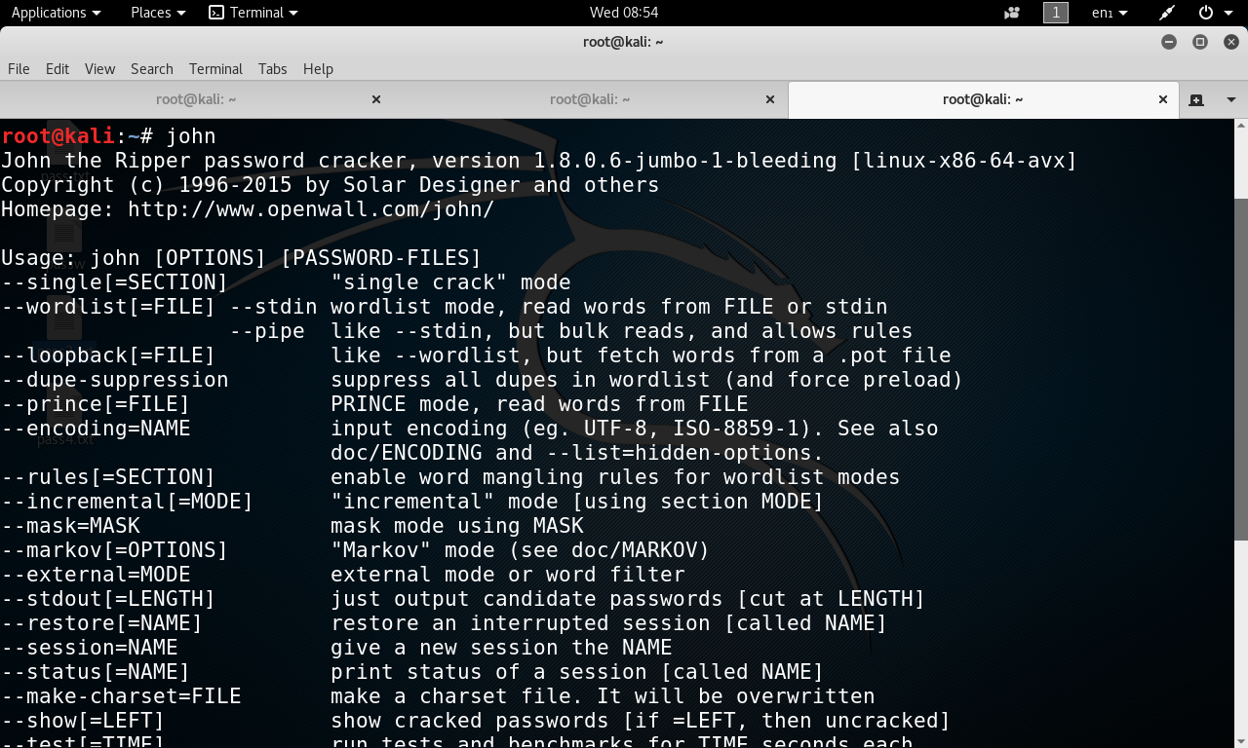

**Step2:** open terminal and type the given below terminal

**Syntax:** John –format=raw-md5 <input file( dictionary file)> <output file<hash file>)

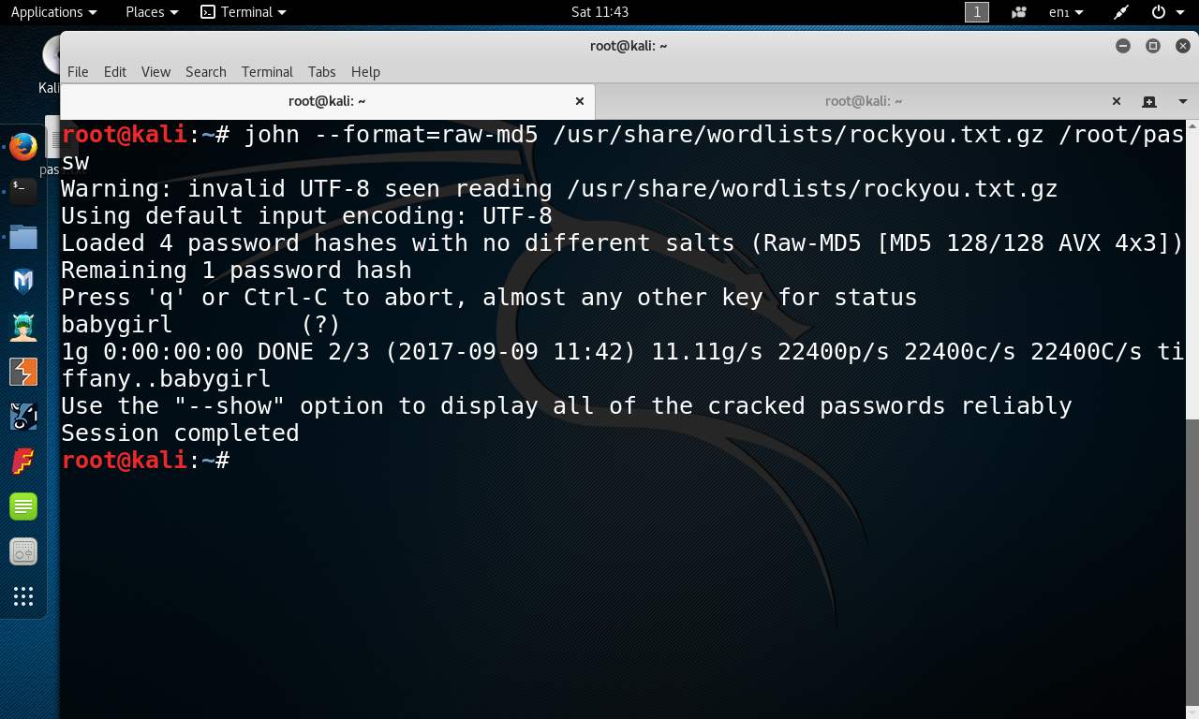

Step3: To show all cracked passwords list, use **show** command

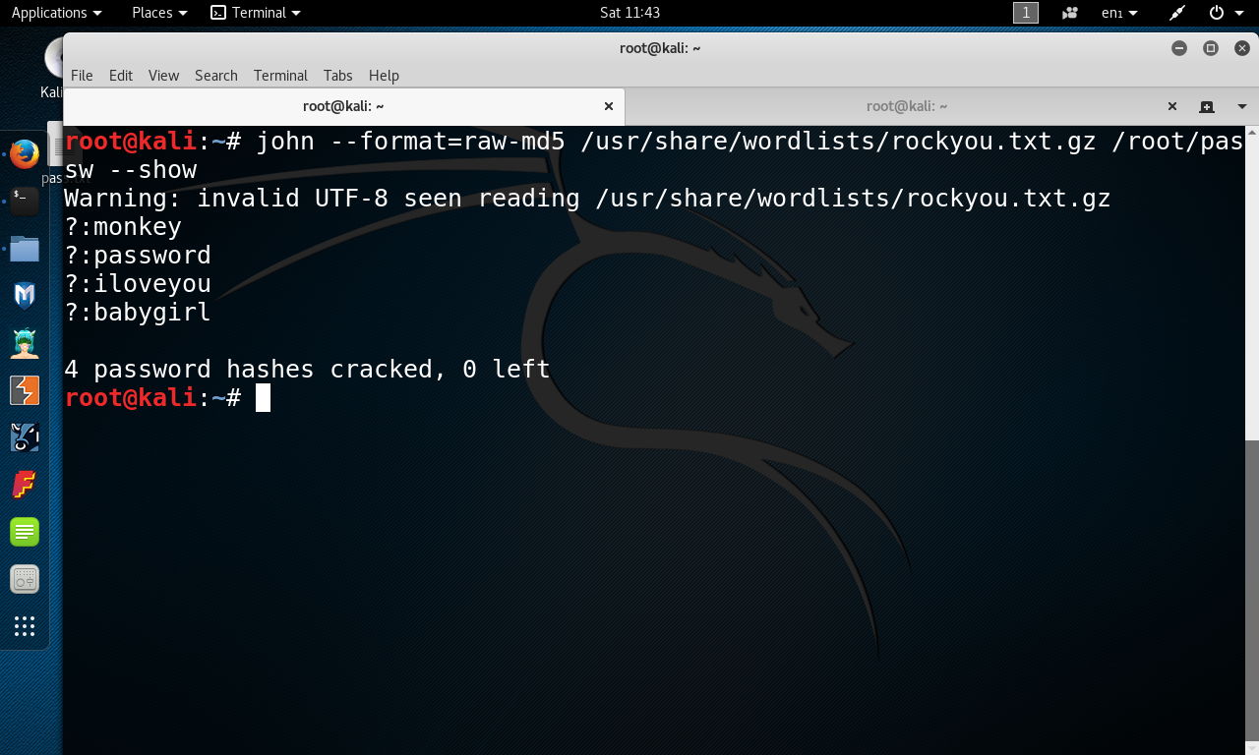

**How does John The Ripper compare to**[**THC Hydra?**](https://www.concise-courses.com/hacking-tools/password-crackers/thc-hydra/)  
 The easiest way to describe the difference between John the Ripper (JTR) and The Hydra is that JTR is an offline password cracker while Hydra is an online password cracker.





